Spiral 2 – Member 3 Completion Report
Project: UML to SQL Schema Generator
Spiral: Spiral‑2
Member Role: Member‑3 – Schema Testing & Verification
Name: Aayush Pathrabe

1. Objective
The objective of my work in Spiral‑2 was to verify that the SQL schema generated by the system works correctly in a real MySQL environment. The generated SQL script (schema.sql) was executed in MySQL to confirm that database tables, attributes, and datatypes were created properly.
This testing step ensures that the UML‑to‑database conversion pipeline produces valid SQL that can be executed without errors.

2. System Pipeline Used
The project pipeline developed by the team is shown below:
UML XMI File
↓
Parser (Spiral‑1)
↓
Validator (Spiral‑1)
↓
Type Mapper (Spiral‑2 Member‑1)
↓
Schema Generator (Spiral‑2 Member‑2)
↓
Generated SQL File (schema.sql)
↓
MySQL Execution & Testing (Spiral‑2 Member‑3)
My responsibility was to test the final SQL output in MySQL.

3. Testing Procedure
The following steps were performed to test the generated database schema.

Step 1 – Run the Generation Pipeline
Command used:
python generate.py model_simple.xmi
This command parses the UML model and generates the SQL schema file.
Screenshot – Running the Pipeline:
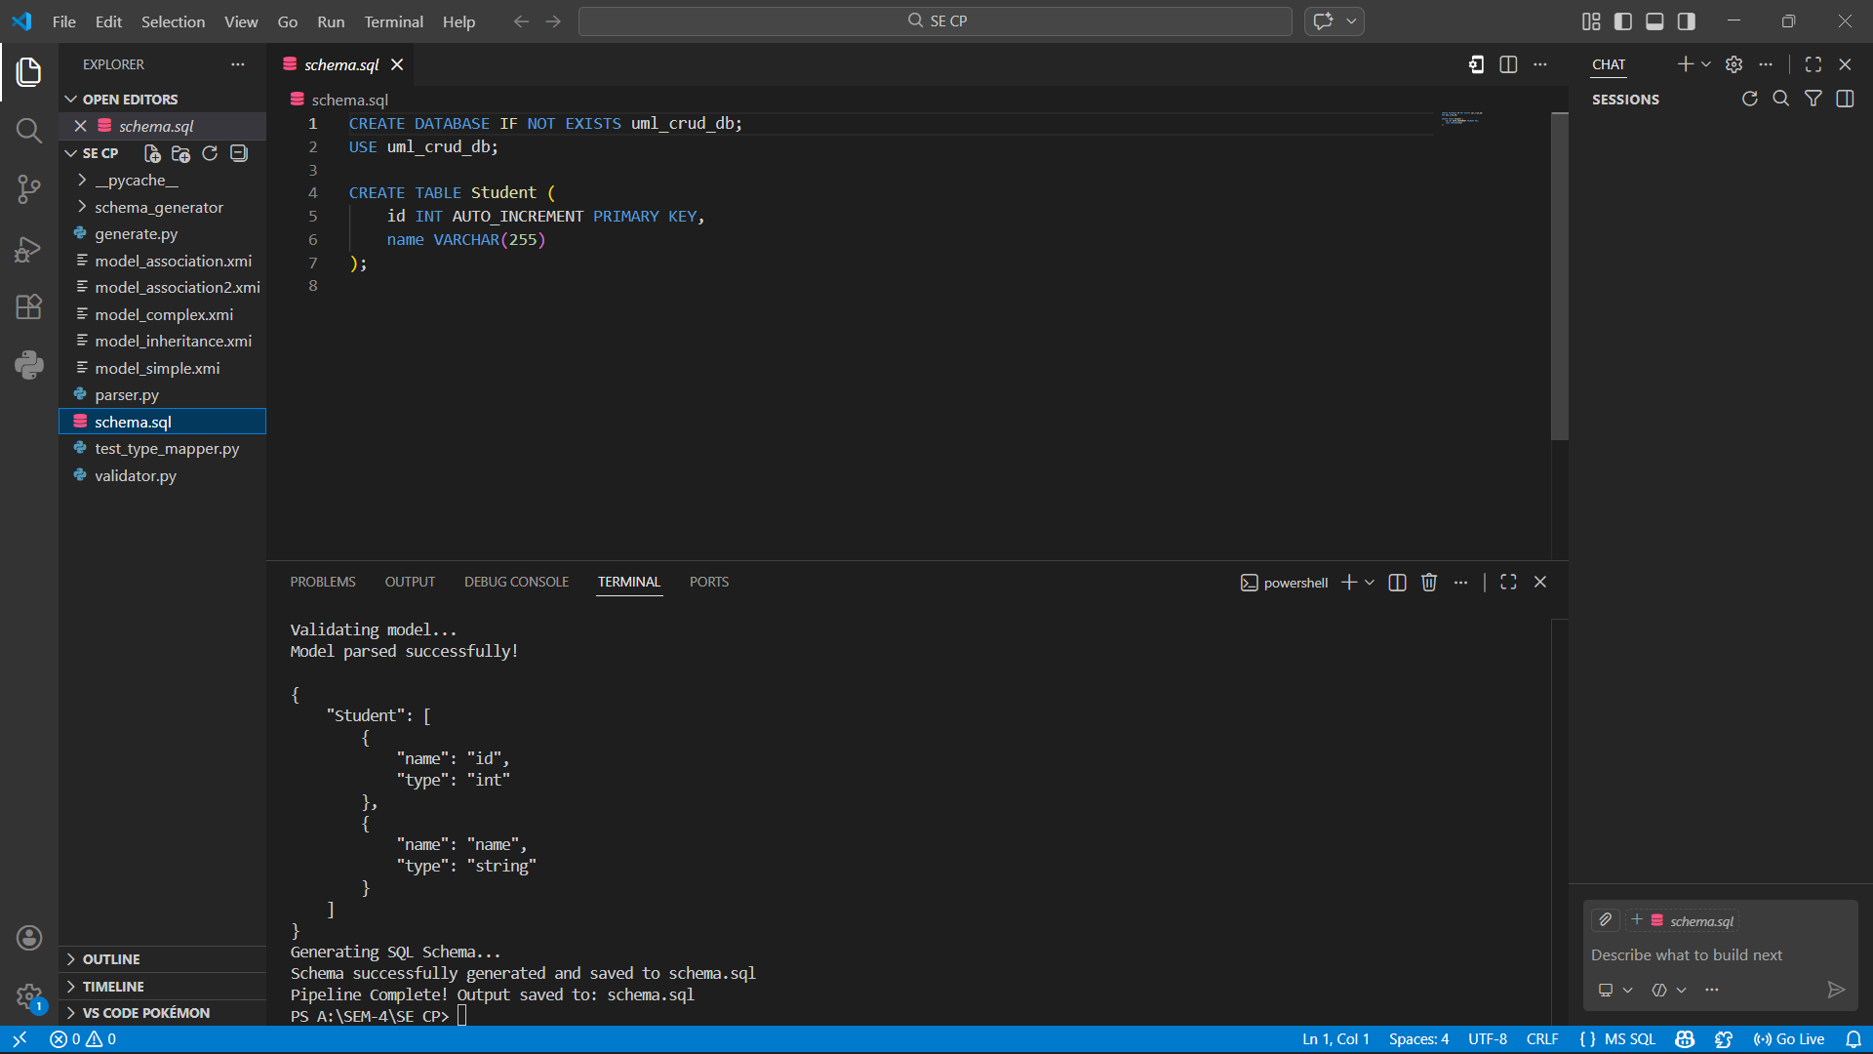

Step 2 – Verify Generated SQL File
After running the pipeline, the file schema.sql is created automatically.
This file contains SQL commands such as:
CREATE DATABASE uml_crud_db;
CREATE TABLE Student (...);

Step 3 – Start MySQL Server
MySQL was started using the following command:
mysql -u root -p
After entering the password, the MySQL console opened successfully.
Screenshot – MySQL Login:
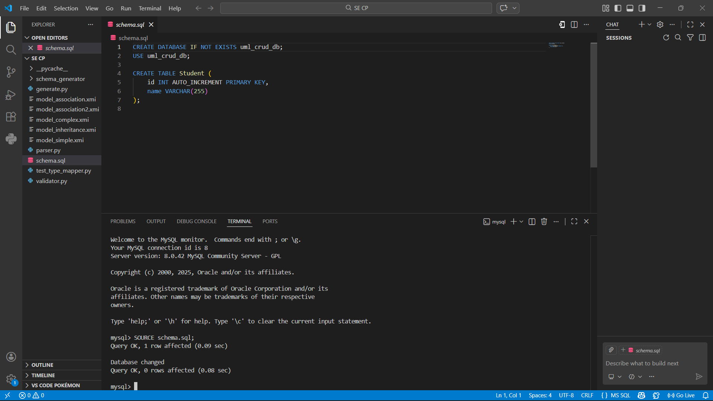

Step 4 – Execute Generated Schema
The generated schema was executed using:
SOURCE schema.sql;
This command creates the database and tables defined in the schema.

Step 5 – Verify Tables in Database
To confirm table creation, the following command was executed:
SHOW TABLES;
This displays all tables created from the UML model.
Screenshot – Tables Created:
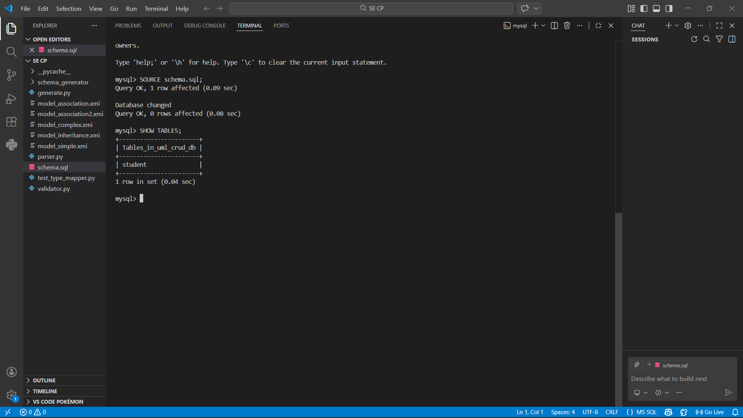

Step 6 – Verify Table Structure
To inspect table columns and datatypes, the command used was:
DESCRIBE person;
This confirms that attributes and data types are correctly mapped.
Screenshot – Table Structure:
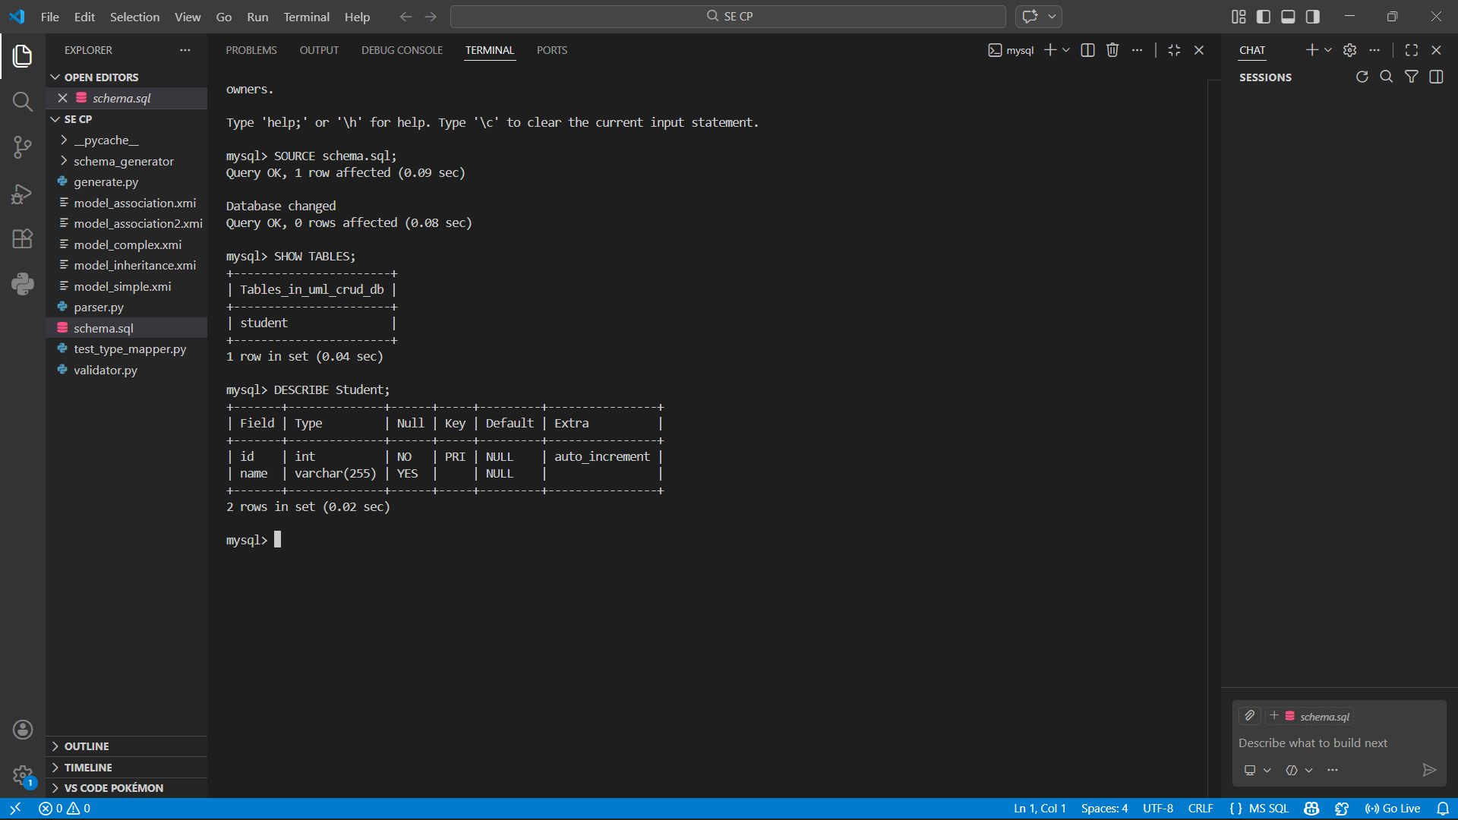

4. Test Models Used
Multiple UML models were tested to ensure the system works for different scenarios:
- model_simple.xmi
- model_complex.xmi
- model_association.xmi
- model_association2.xmi
- model_inheritance.xmi
Each model was processed through the pipeline and verified in MySQL.
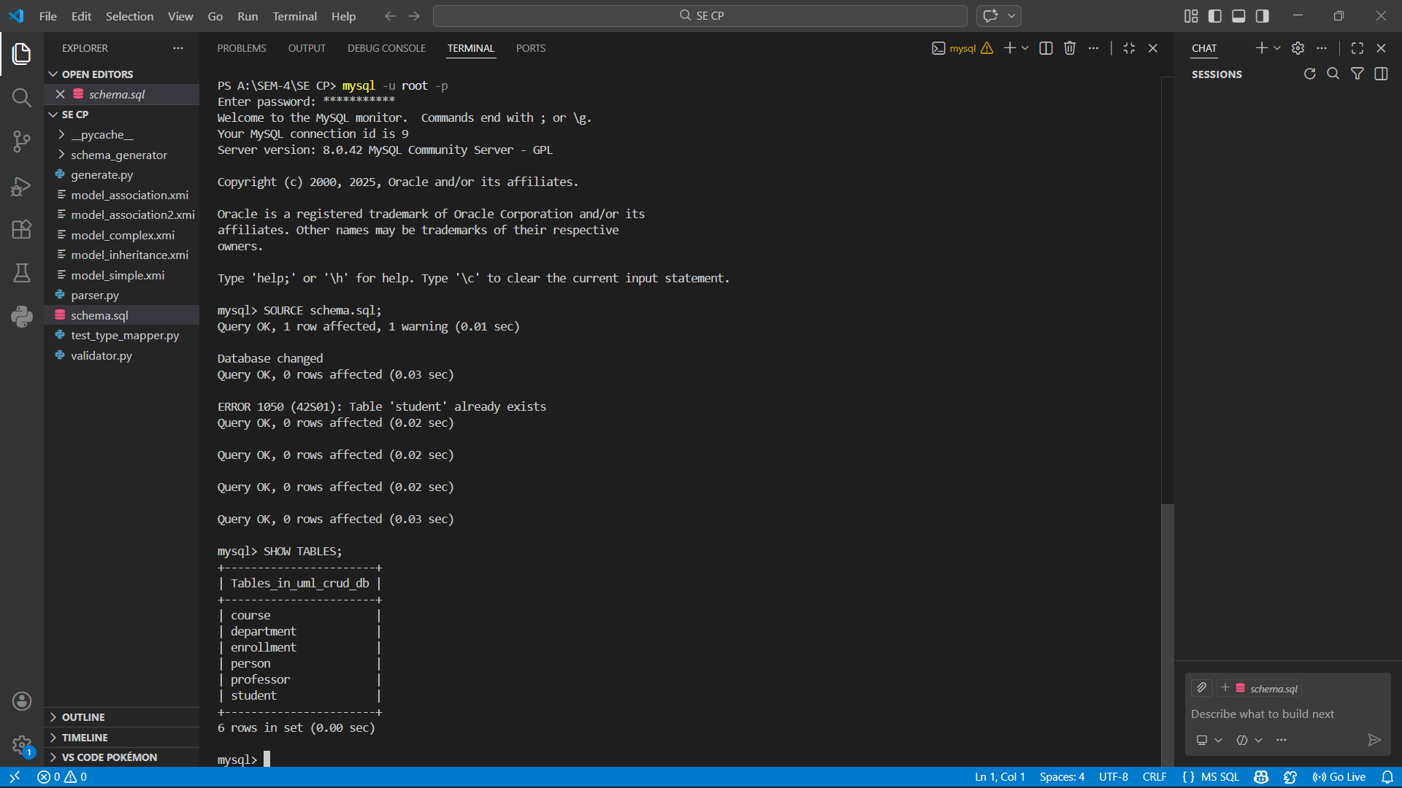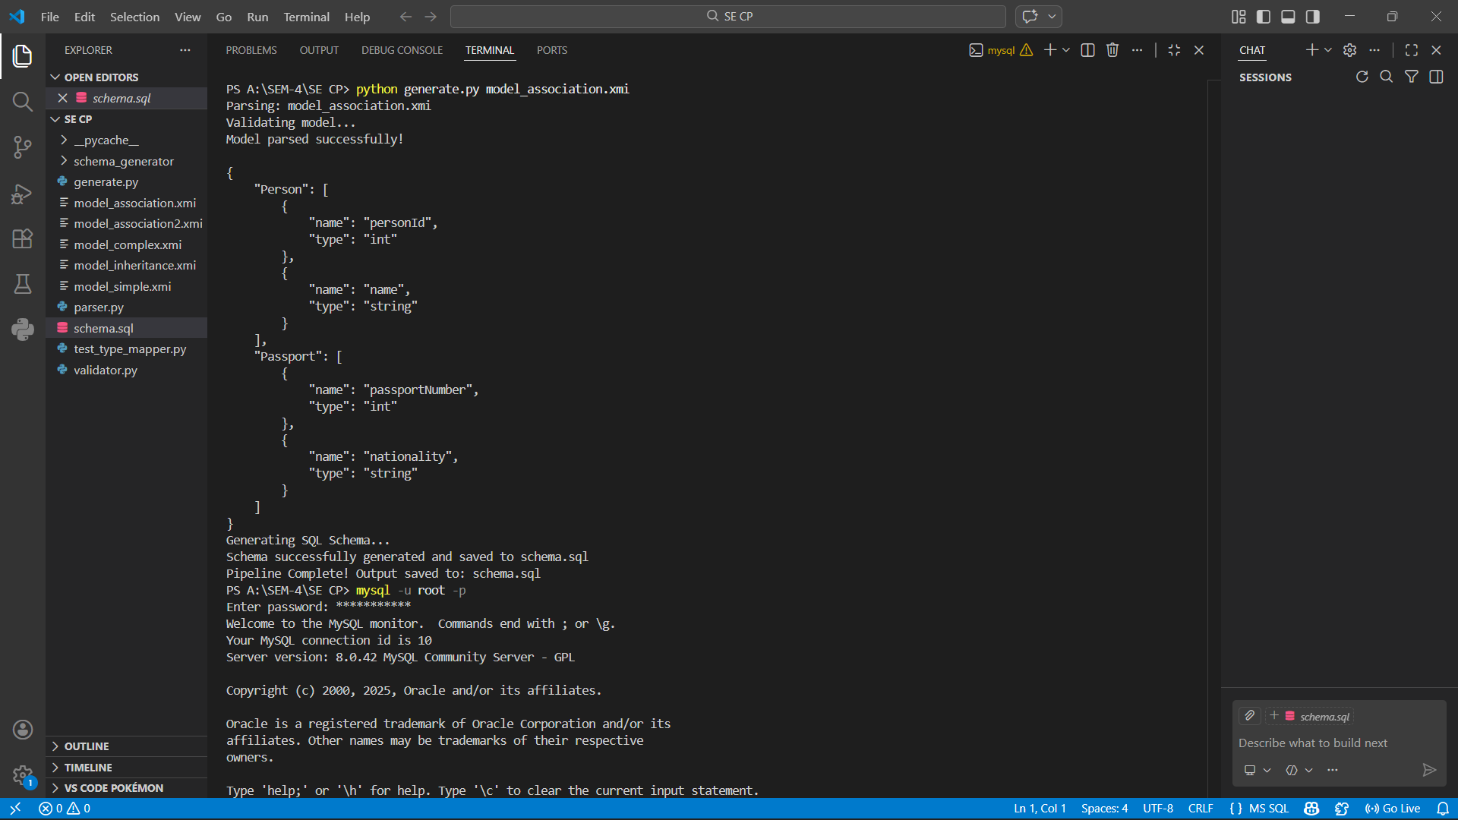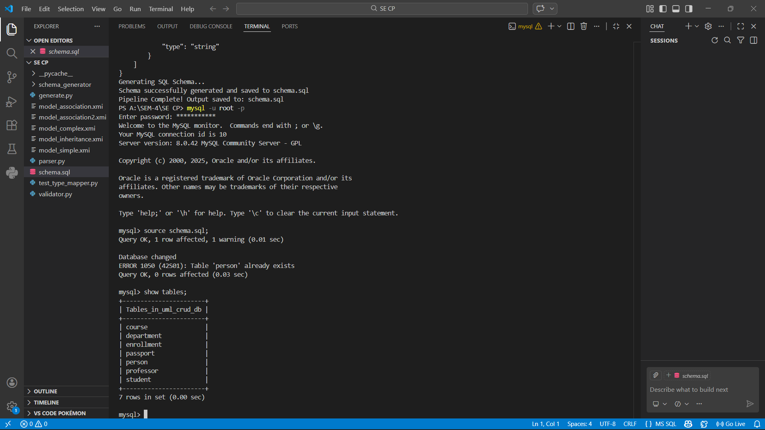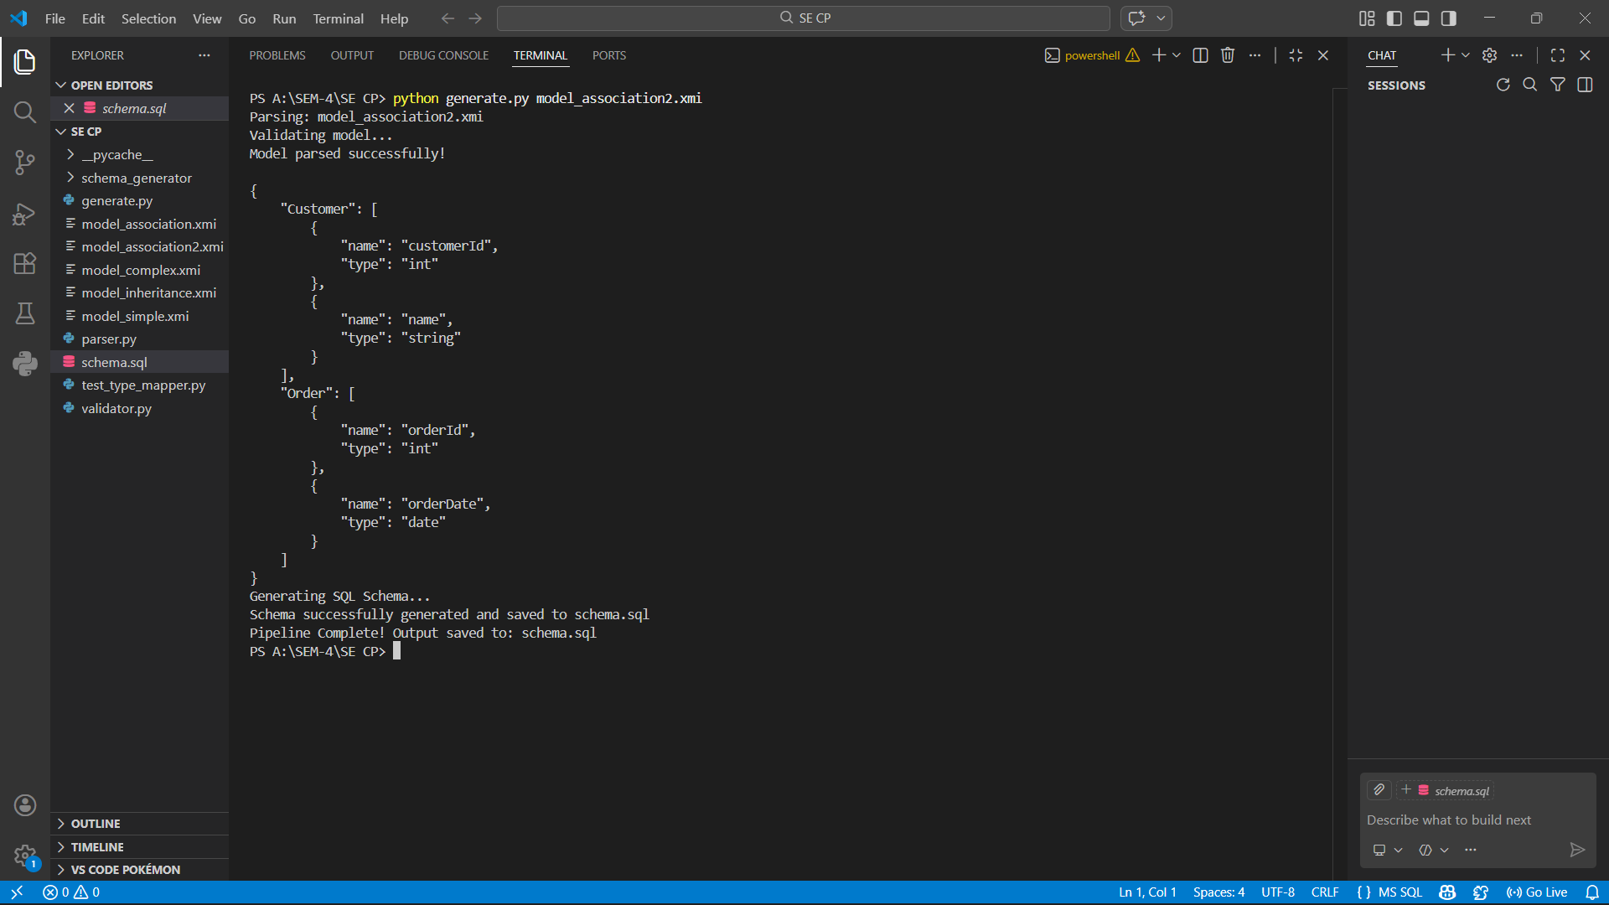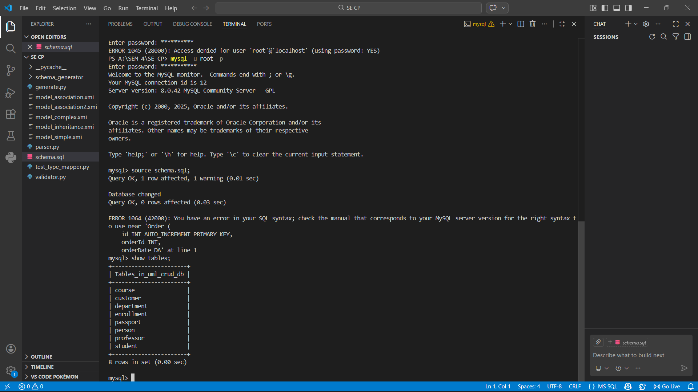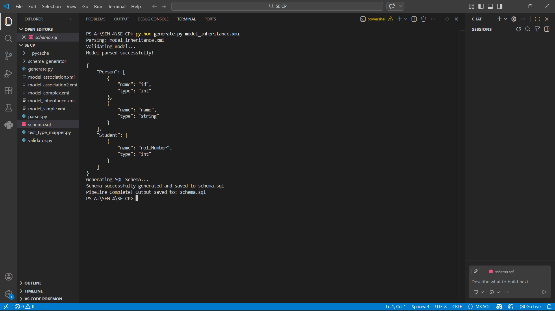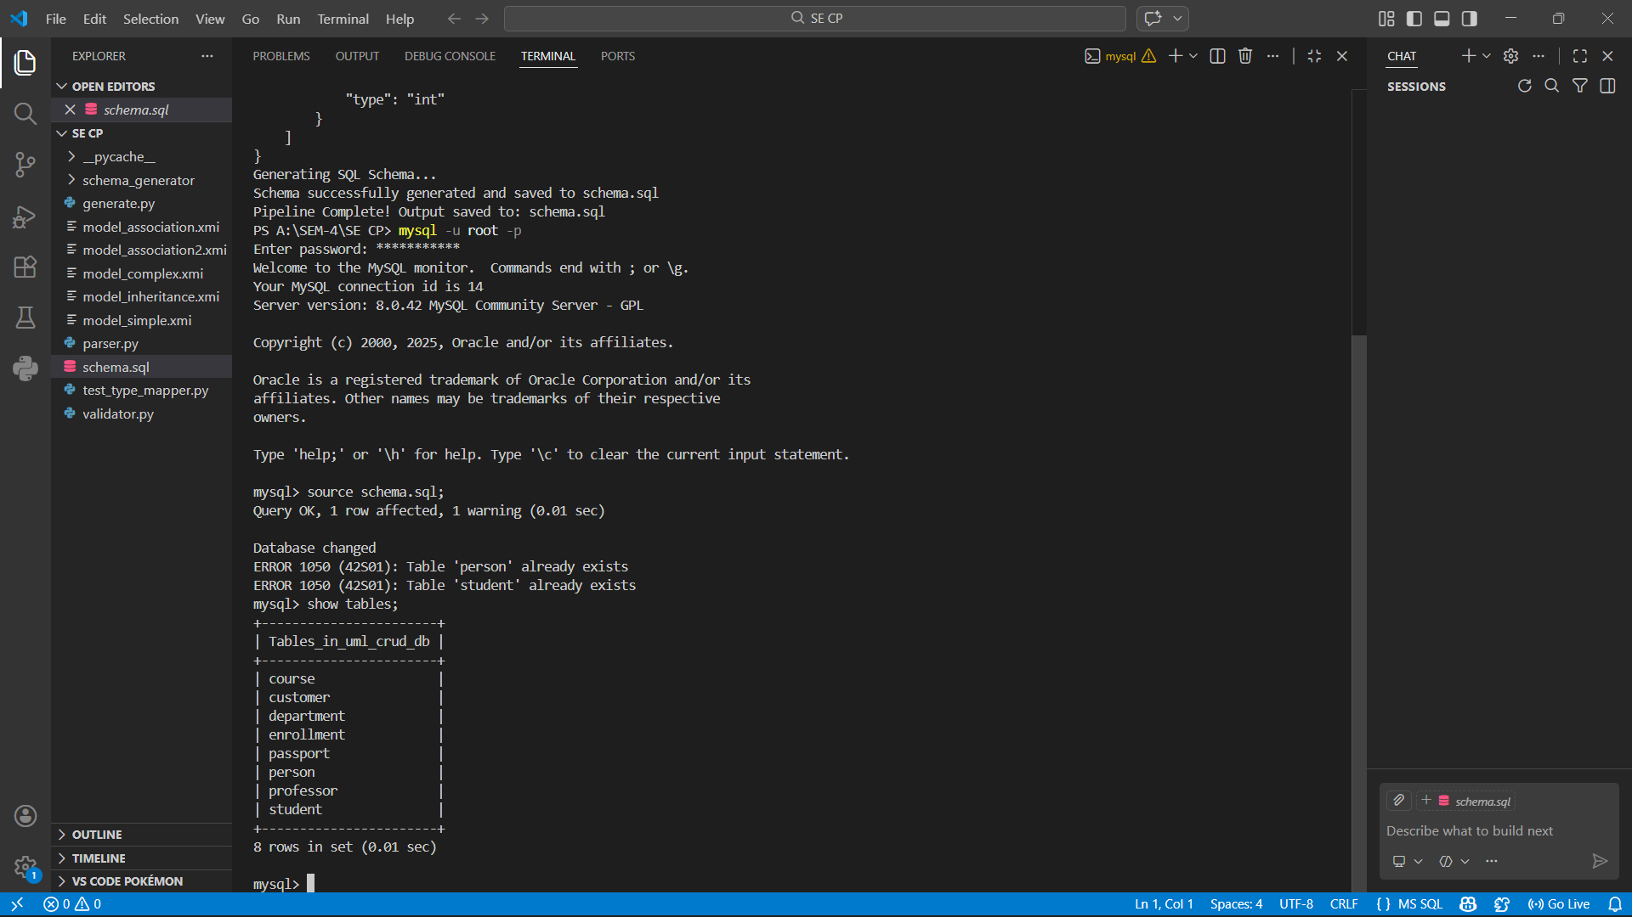

5. Results
The following results were observed during testing:
- SQL schema was generated successfully.
- Database tables were created correctly in MySQL.
- UML datatypes were correctly mapped to MySQL datatypes.
- Primary keys were added automatically.
- The generated schema executed without critical errors.

6. Conclusion
The testing confirmed that the UML‑to‑SQL schema generation pipeline works correctly. The generated schema.sql file successfully created database tables in MySQL with correct attributes and datatypes.
This verifies that the system can automatically convert UML models into executable database schemas.

7. Contribution
My contribution to Spiral‑2 included:
- Testing the generated SQL schema in MySQL
- Verifying table creation and datatype mapping
- Validating the correctness of the database schema
- Documenting the results with screenshots
This ensures that the system output is reliable and ready for the next stage of development.

